Encoding–Decoding Constellations I: Engravings

Pieces:
Disintegrating (State of Mind), 2024
Yearning (for a Fantasy), 2025

Medium:
Laser engraving on printmaking paper

Dimensions:
11 × 14 in each

Description:
This series stages a tension between structure and surprise through constellation forms that deliberately depart from the strict symmetries of the classical Islamic constellation patterns that inspired them.

The works build on an encoding–decoding framework developed by Rebecca Lin and Craig S. Kaplan that translates between constellation patterns and mathematical graphs, revealing graphs as an alternative representation for analyzing and designing constellations.

In this framework, a pattern is first specified as a graph: vertices represent stars and edges encode their adjacencies. A decoding step then realizes this abstract structure geometrically through a circle packing, which serves as a scaffold for classical compass-and-straightedge motif construction.

Implemented through custom software, this translation framework allows patterns to be programmed through their combinatorial structure, opening an interactive space for exploration and expressive departures from the classical aesthetic. Order and disorder become controllable parameters. In these pieces, Islamic geometric ornamentation is juxtaposed with fragmented, organic forms that hover between pattern and dissolution.

The designs are laser-engraved on printmaking paper. Because the process burns rather than deposits ink, each line carries subtle variations shaped by heat, paper fibers, and the character of different laser systems. Through extensive experimentation with machines and materials, the engravings developed a delicate tonal surface that sits between algorithmic precision and material interpretation.

Associated Media:
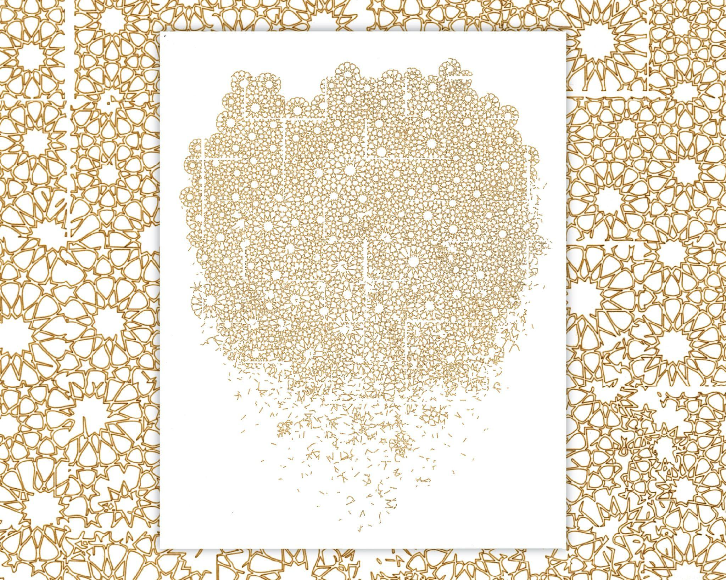
Media 1: Disintegrating (State of Mind).

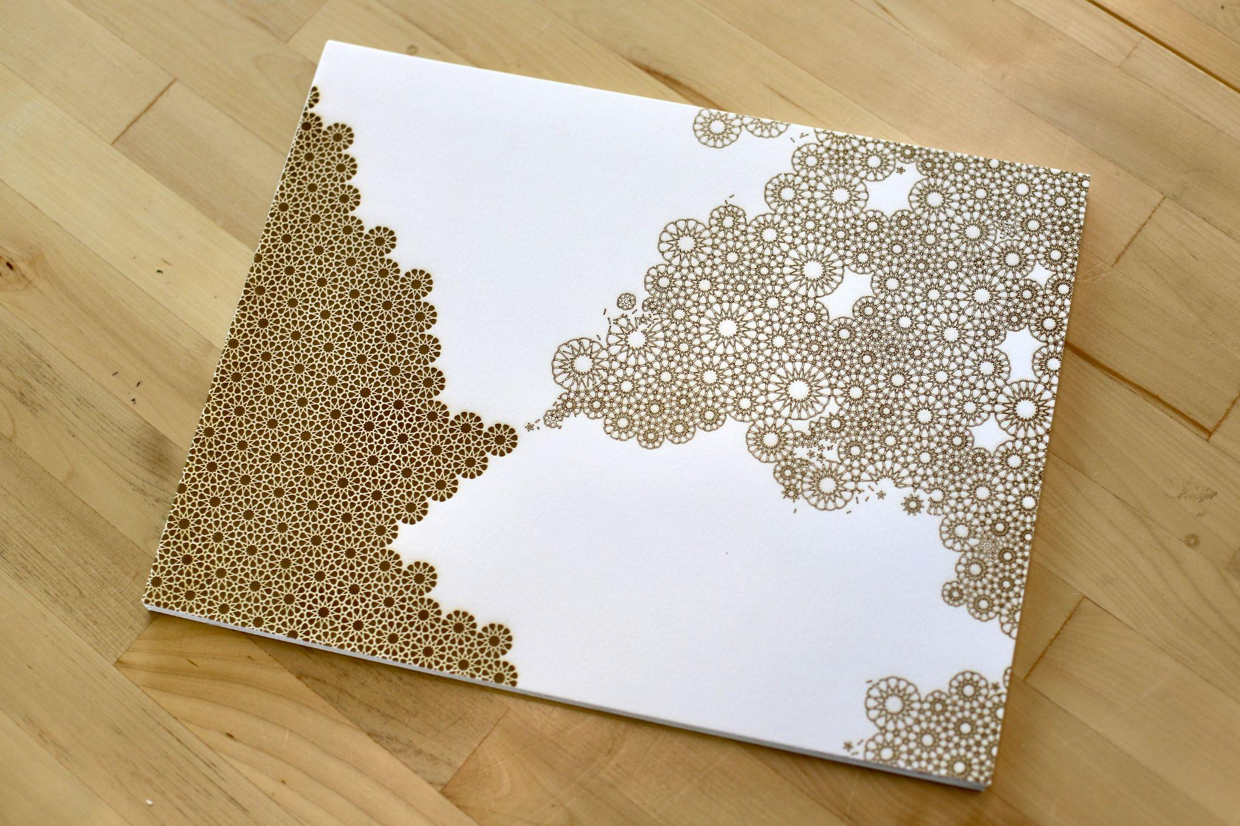
Media 2: Yearning (for a Fantasy).

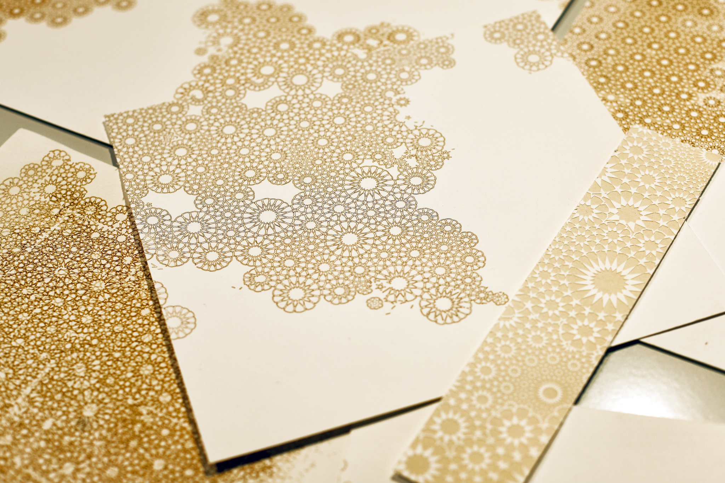
Media 3: Process shot of engraving experiments.

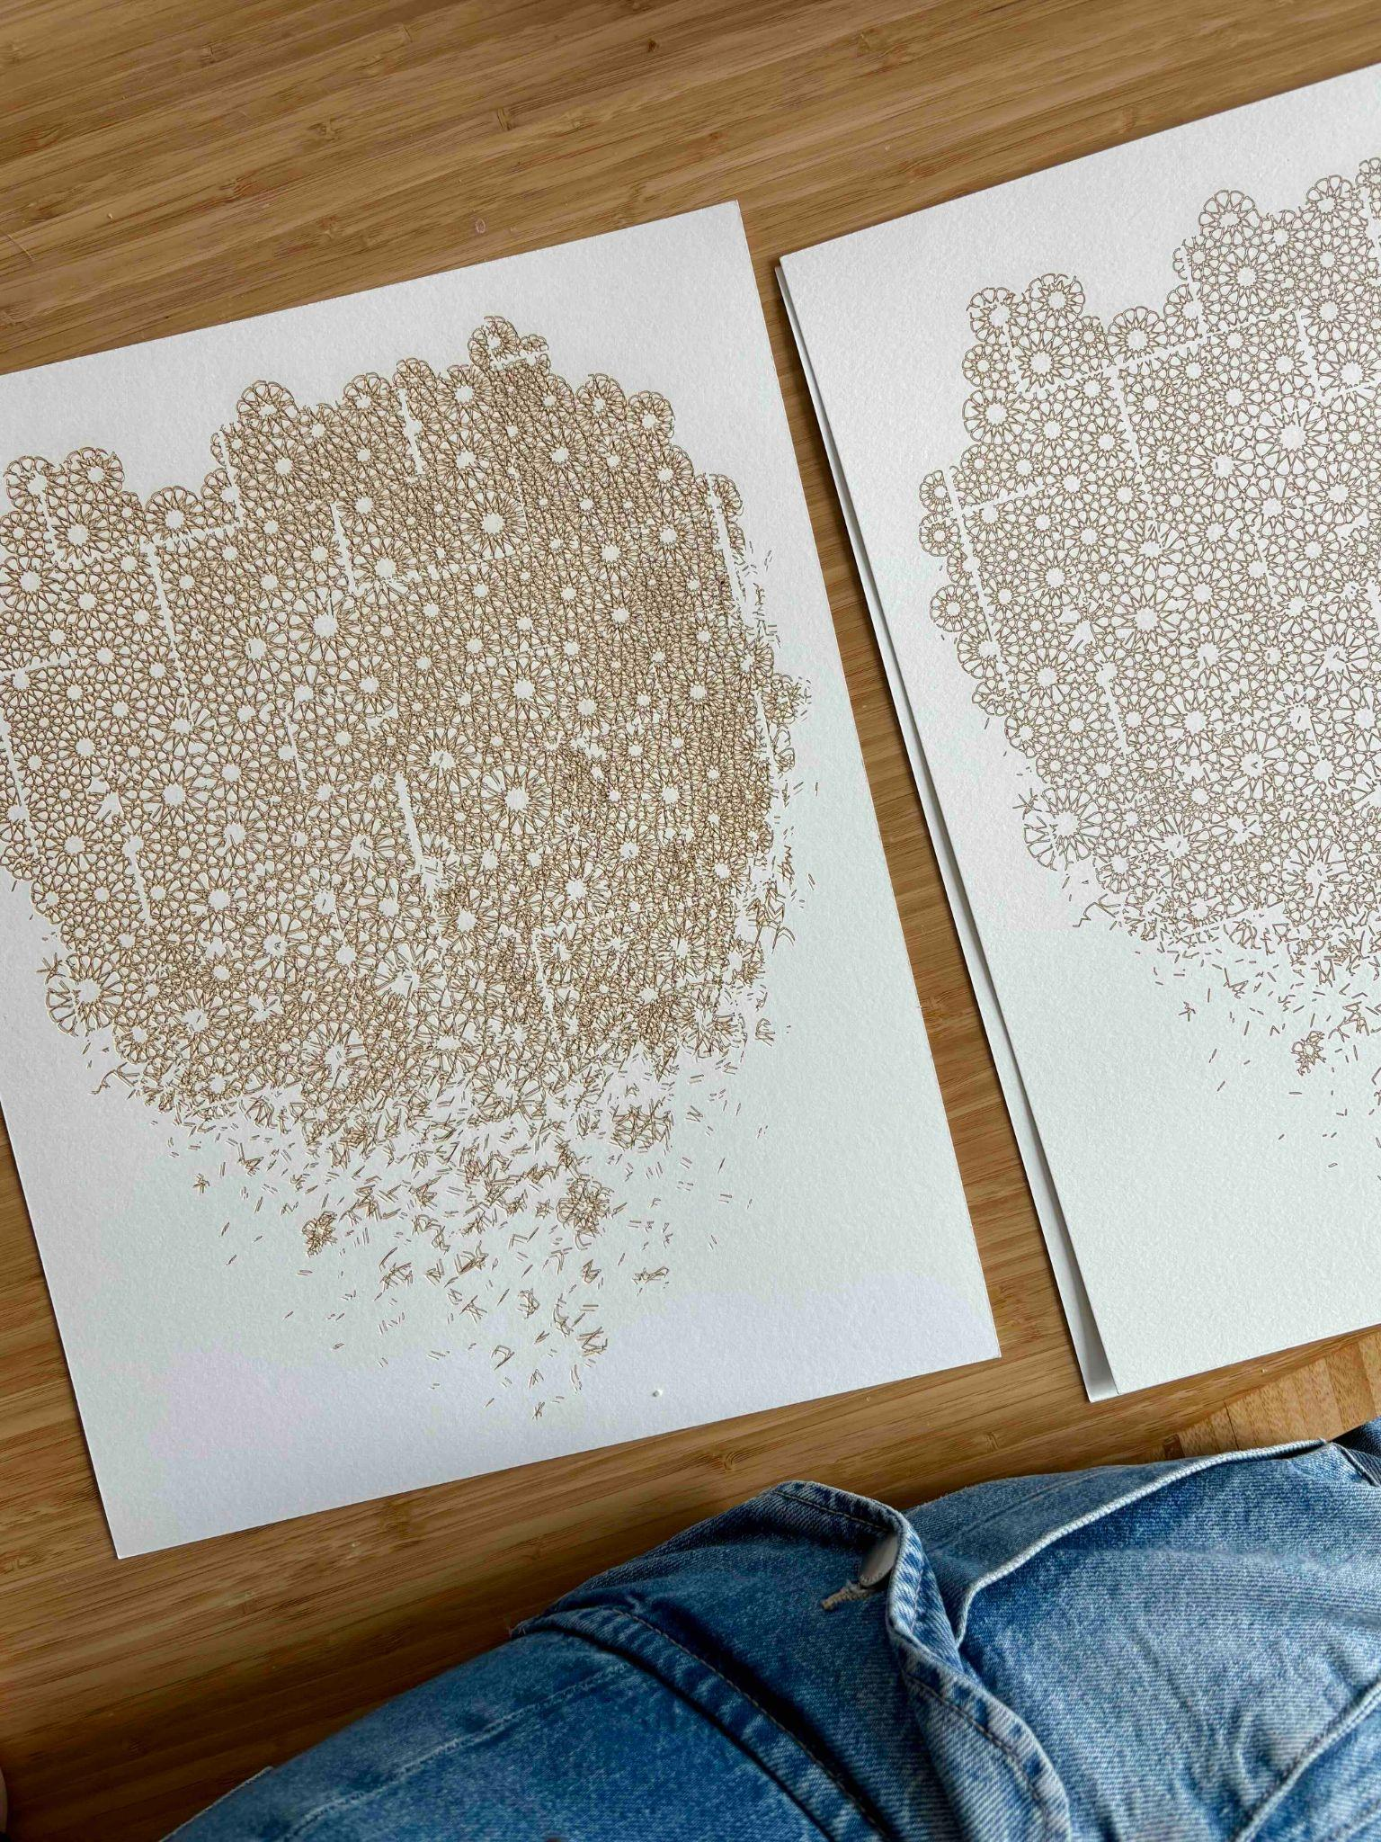
Media 4: Visual effects.

